U.S.I. Systems. Design Build , Panelized Wall Panel Programs for Light Gage Metal Framed Restaurants. ericsdahlin@gmail.com 
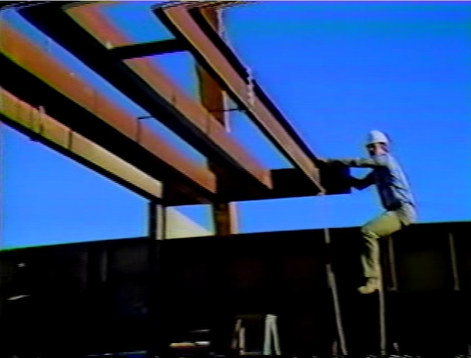
U.S.I. Systems. ericsdahlin@gmail.com North Fulton County Schools Metro Atlanta Ga. Design Build Light Gage Steel Trusses “Specialty Contractor “
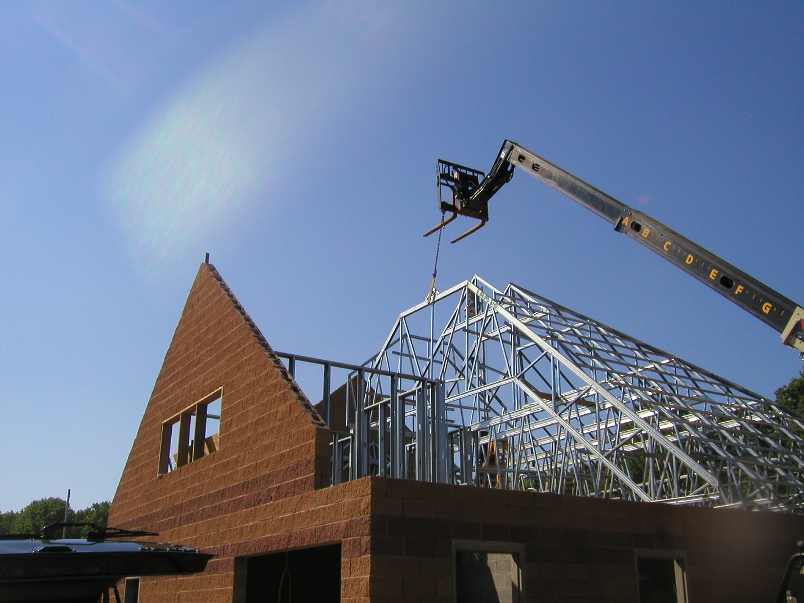
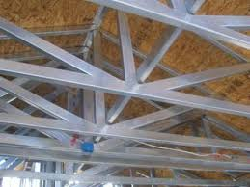
Design Build, Light Gage Trusses Manufactured From Standard C- Studs

Hotel Light Gage Steel Construction
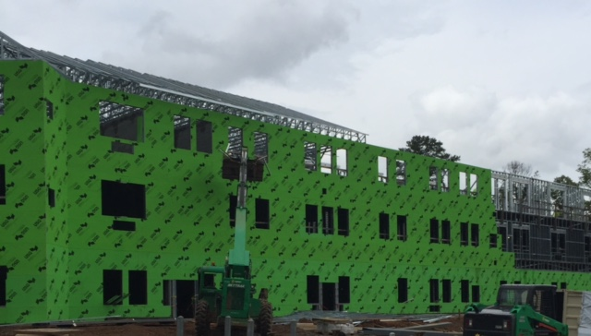
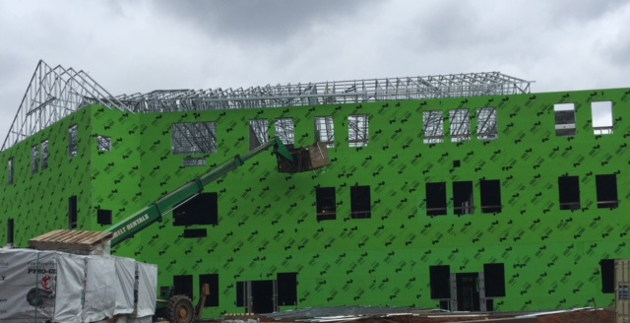

Starbucks Resturant
New Design Red Top Mt Cartersville Ga.
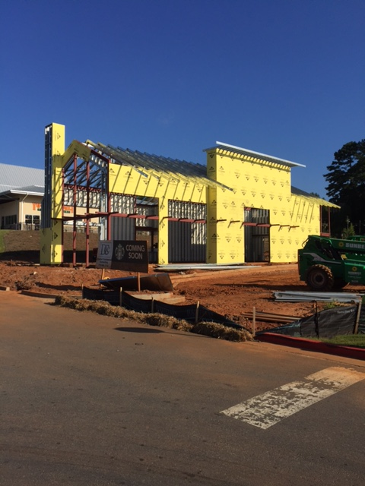

Duluth Ga. Senior Living. ” Specialty Contractor ”
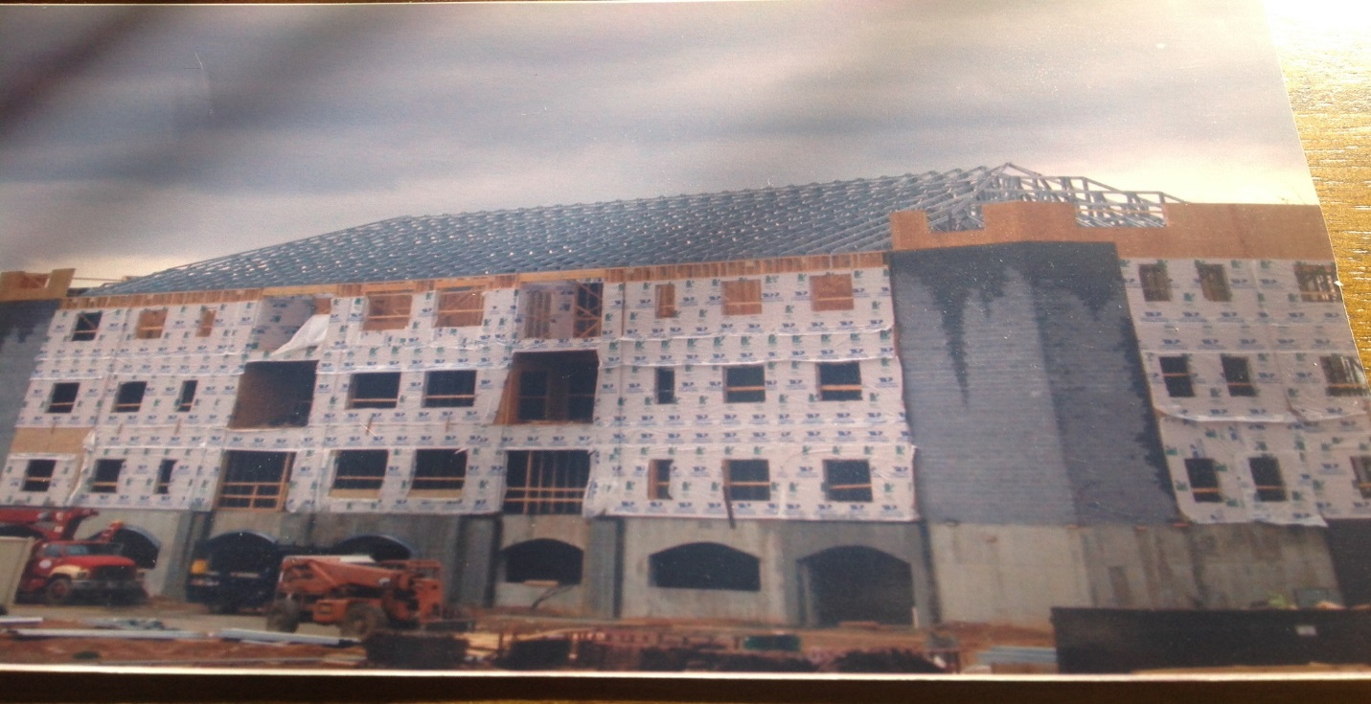
Sheltering Arms Child Center Cobb Co. Ga. Design Build
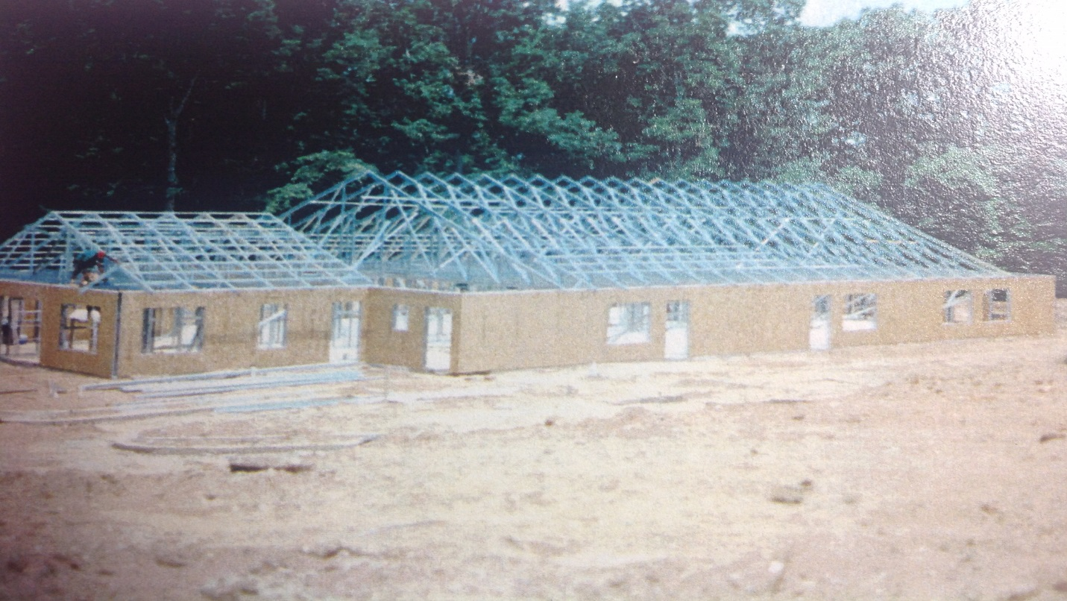

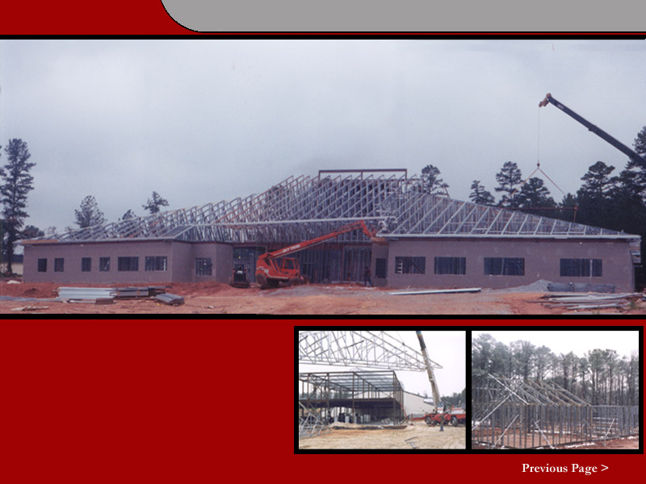
U.S.I. Systems. ericsdahlin@gmail.com Construction Manager 140,000 Sq. Ft. Retirement Village in Lilburn Ga. 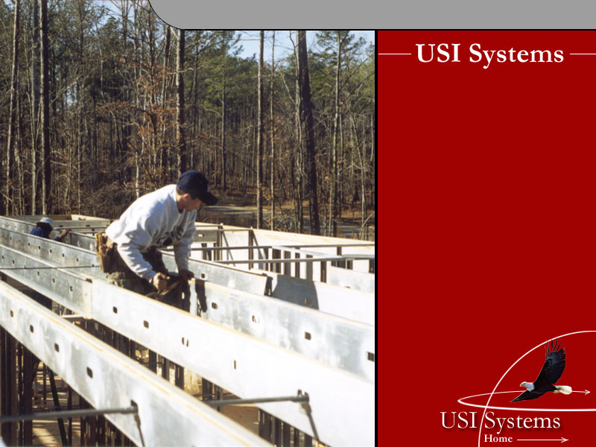
The New Steel Construction Manager
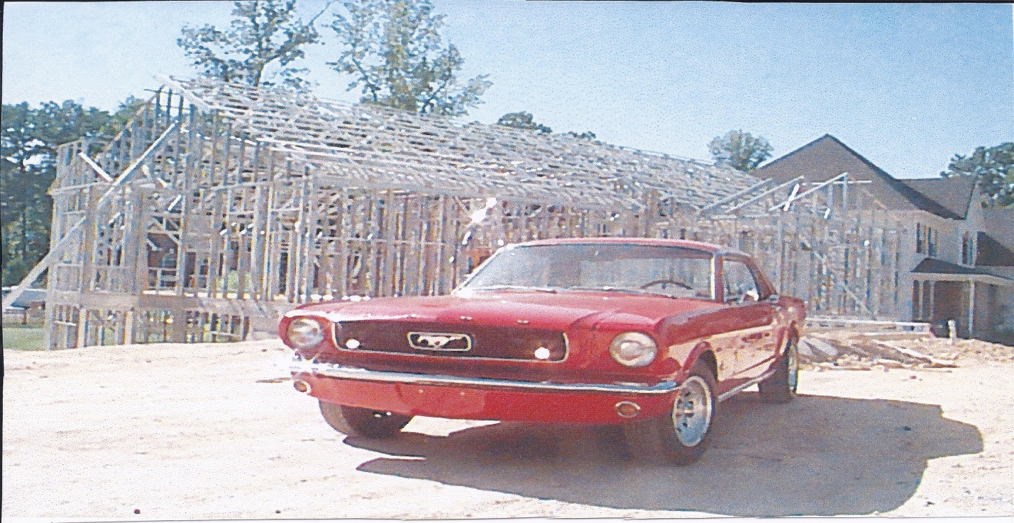

U.S.I. Systems. Design Build, Four Story Facility, Atlanta Ga. ericsdahlin@gmail.com Construction Manager
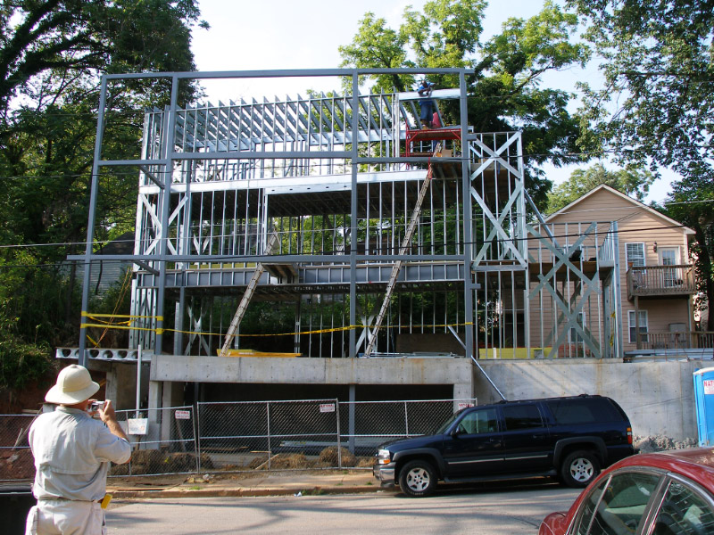
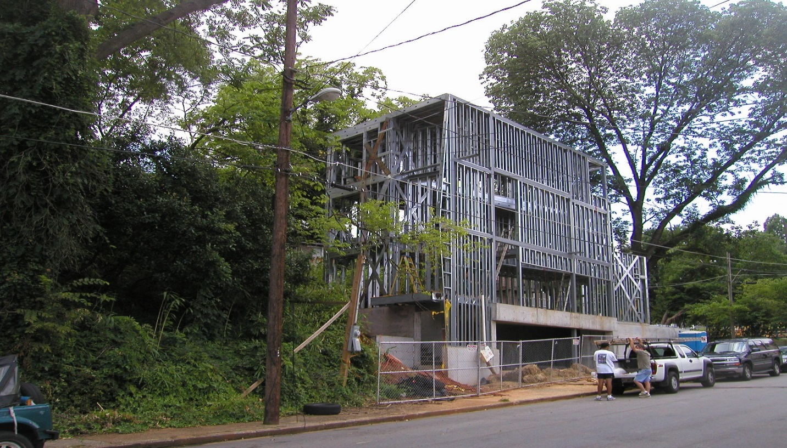

Finished Product
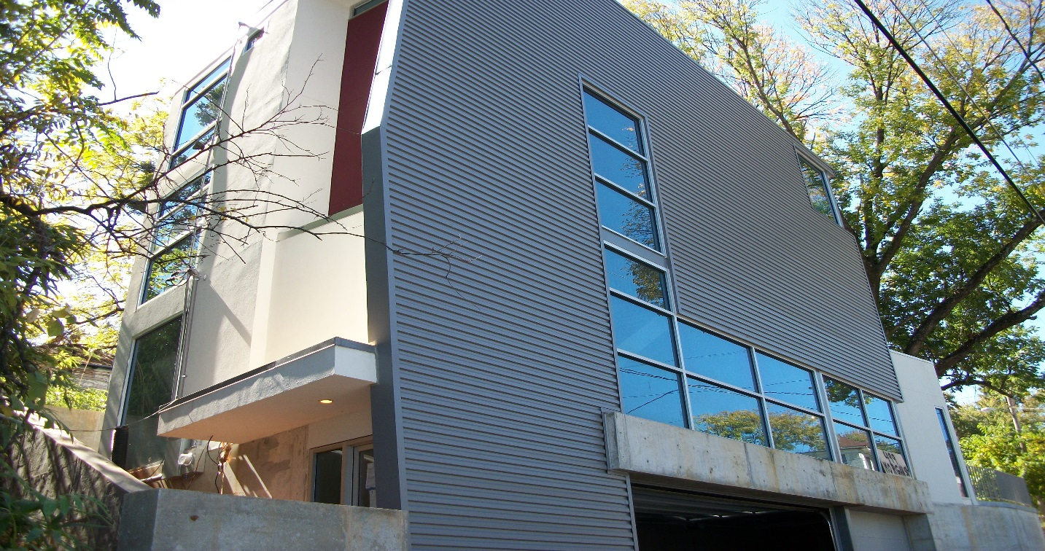

- Design Build, 140 M.P.H. Wind Load, Home …… East Coast of U.S. “Construction Manager”

One Of the First Steel-Framed Homes In North Carolina, 1987
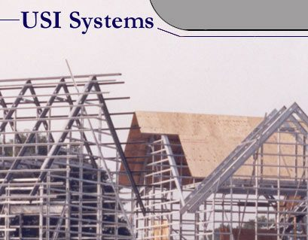

Duplex Offices, Apalachicola, Florida “Construction Manager”
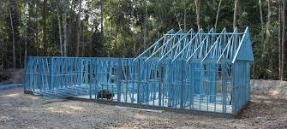

5000 Sq. Ft Home Marietta Ga. Steel Framed. “Construction Manager’s”
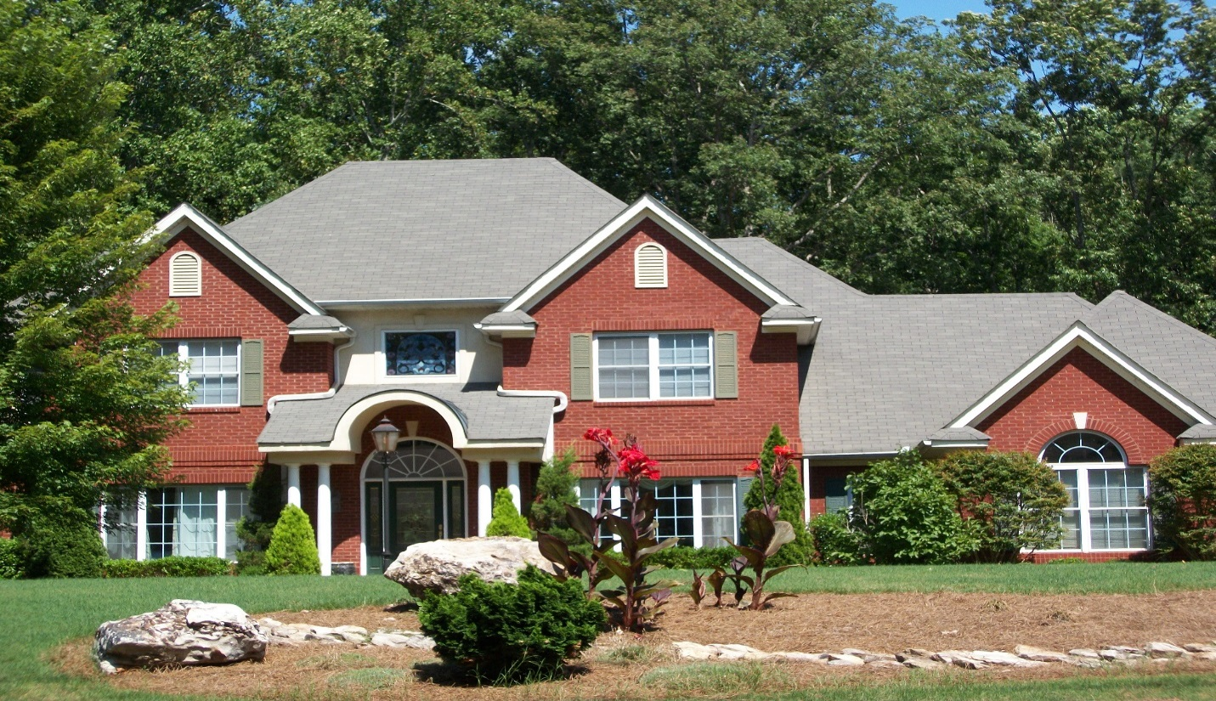
Steel Rafter 10/12 Pitch
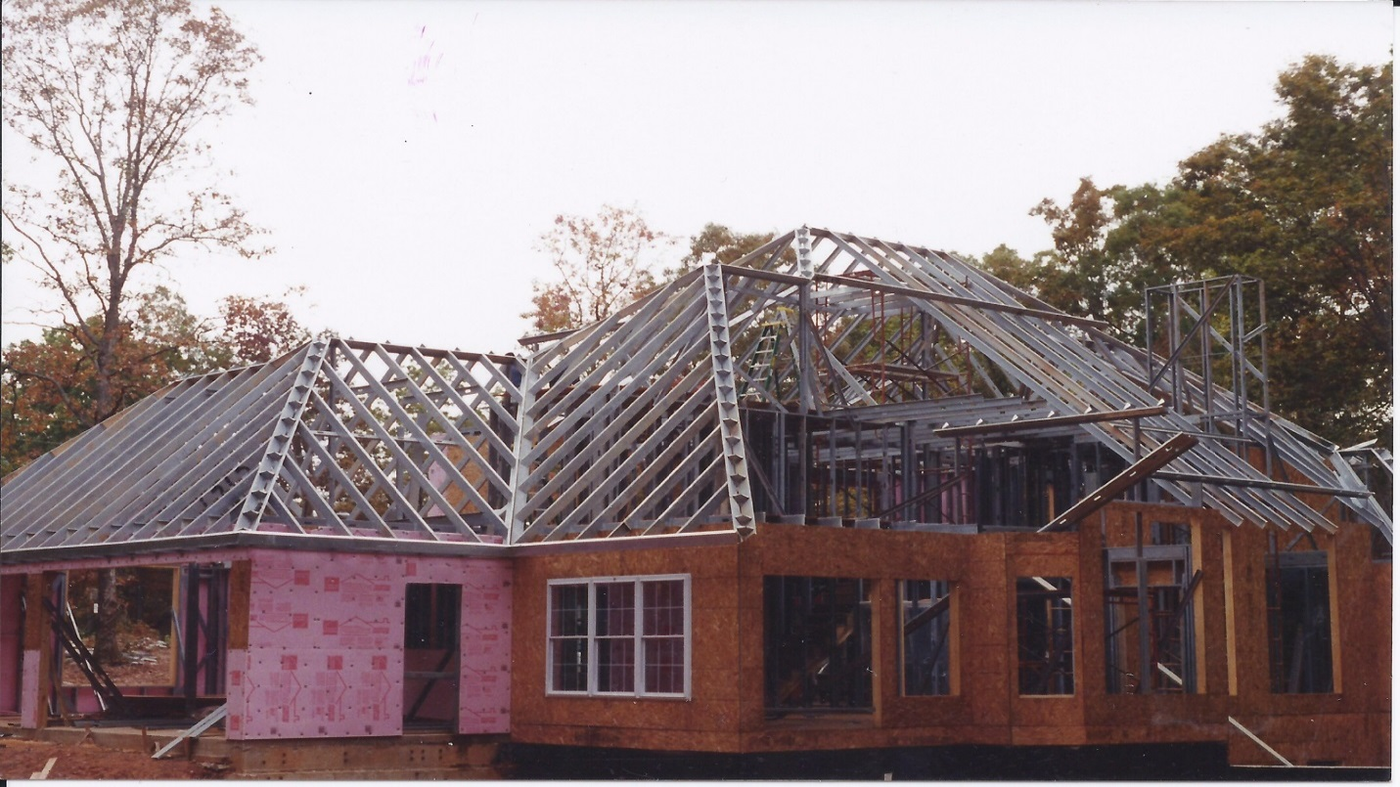

5000 Sq. Ft Country Ranch ………… Maintenance Free Home …………. R- 30 Insulation Value
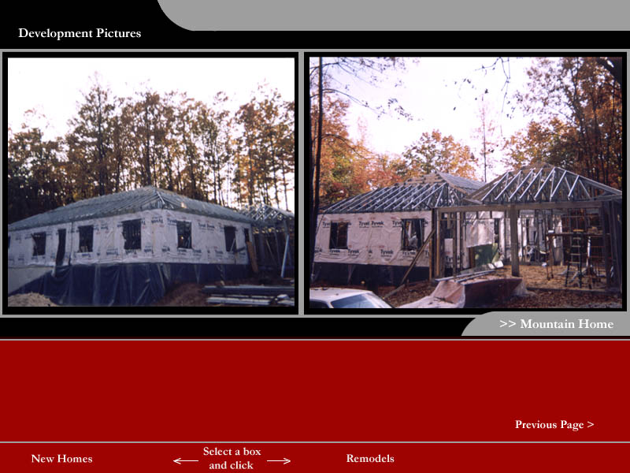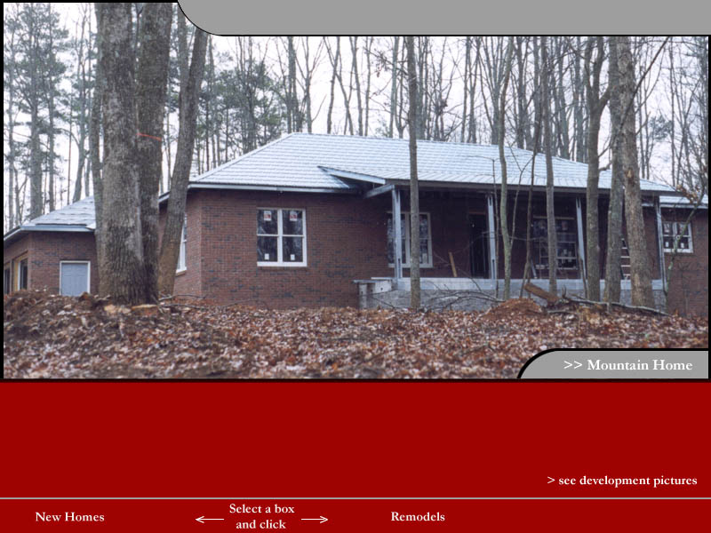

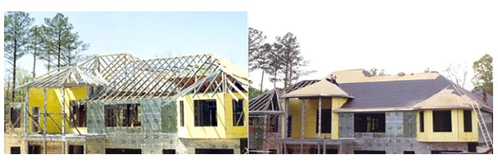
Eagles Landing Community South of Atlanta
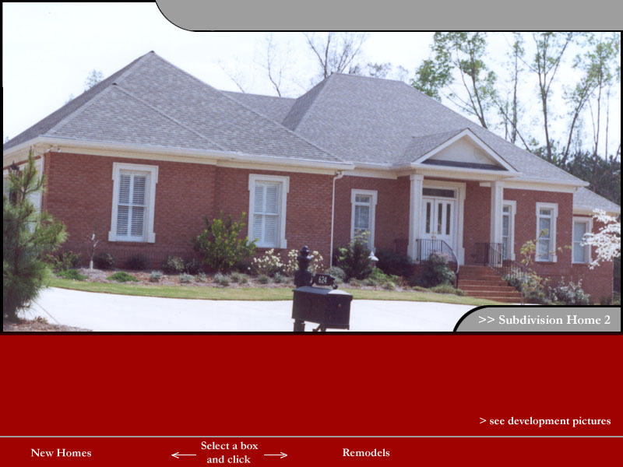

Home Inspection of “New Home” For a Atlanta Executive In Buckhead Ga.
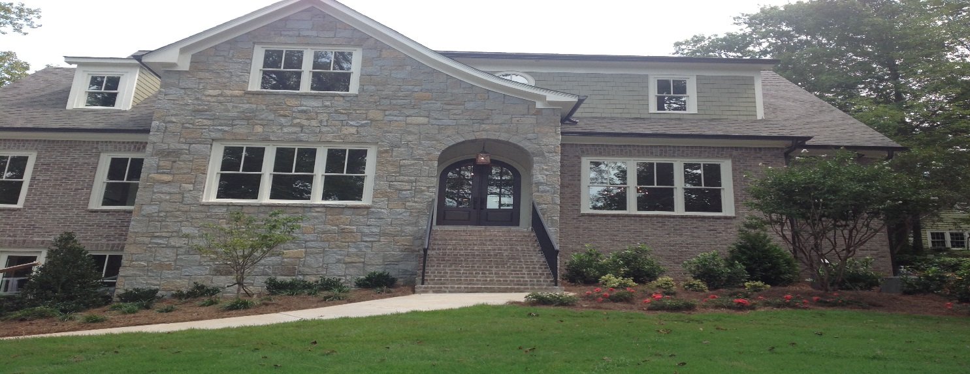

Haiti Shelters

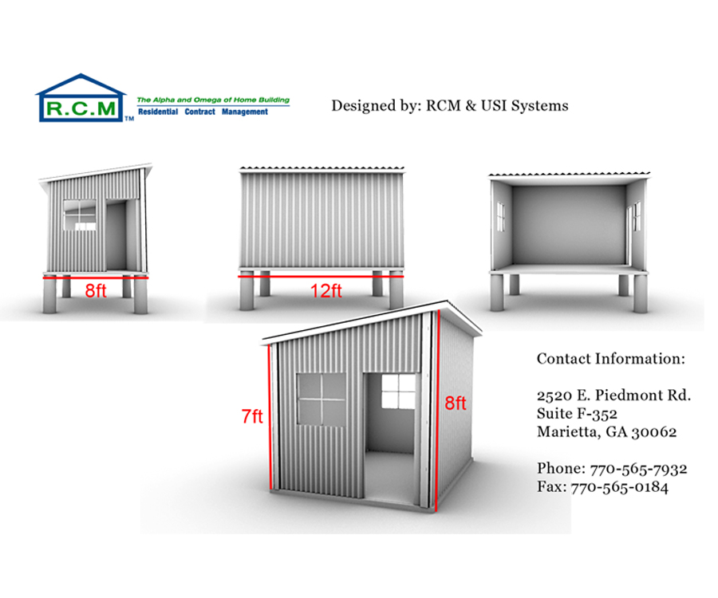

Construction Management of Residential & Commercial Construction
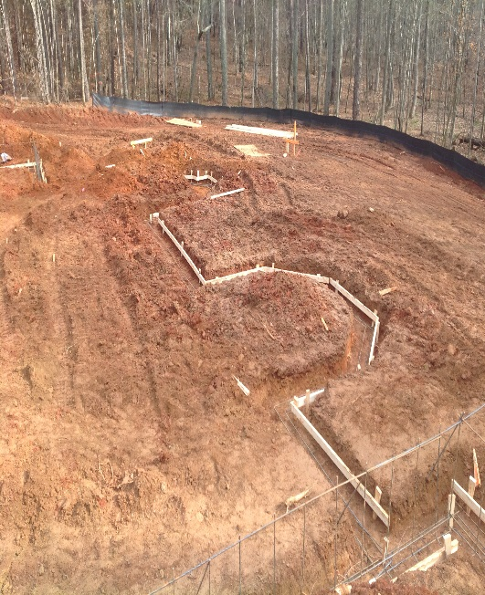
Photo of Eric Dahlin Taken from the Publish Version, The Rebuilding & Restoration of America

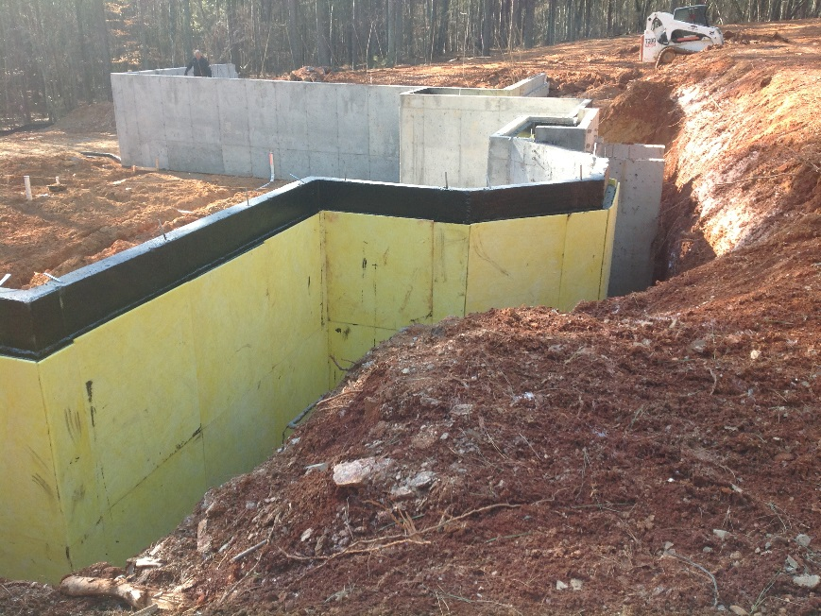

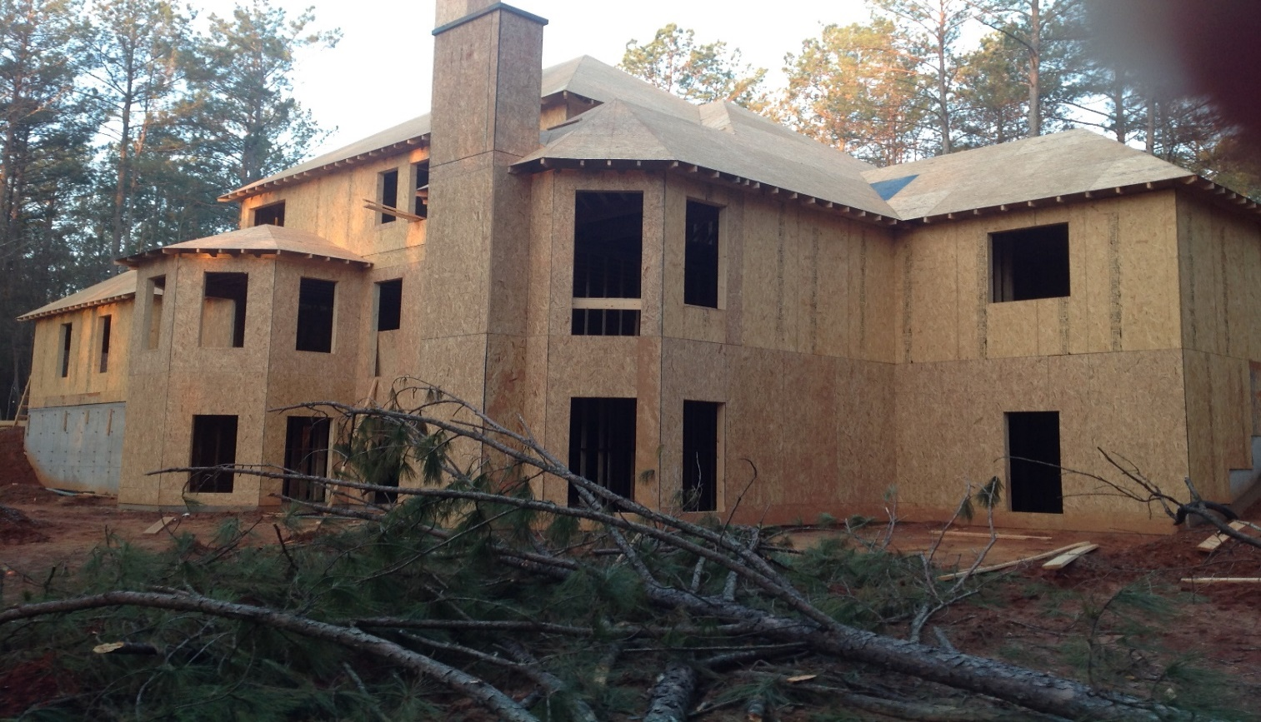
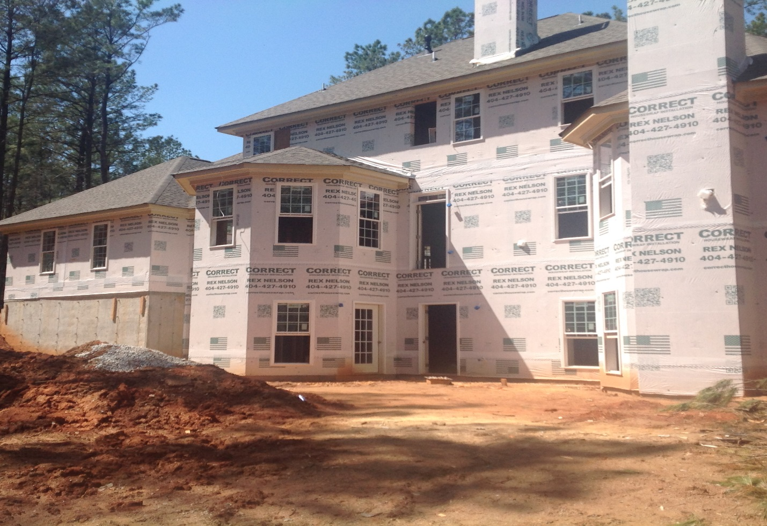

Maintenance Free Brick Home 5000 Sq. ft.
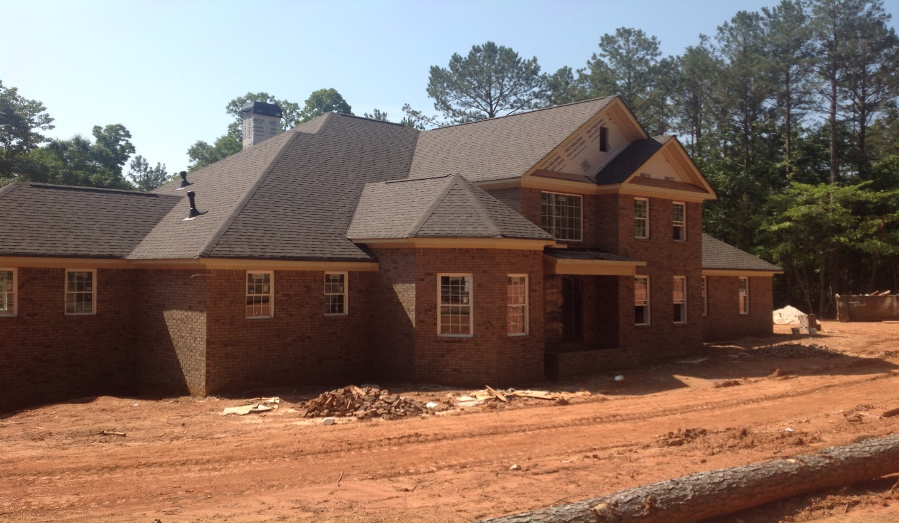
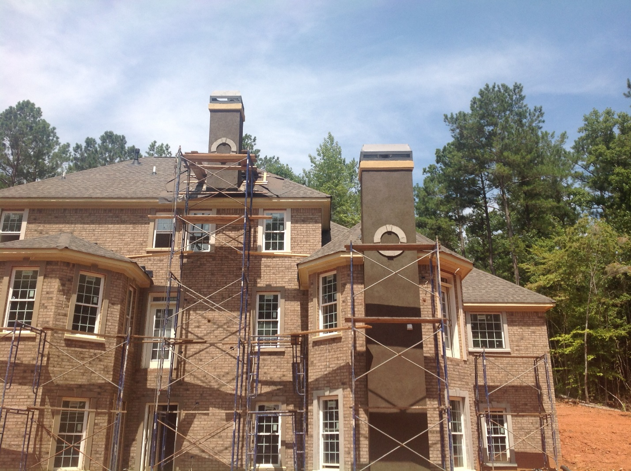

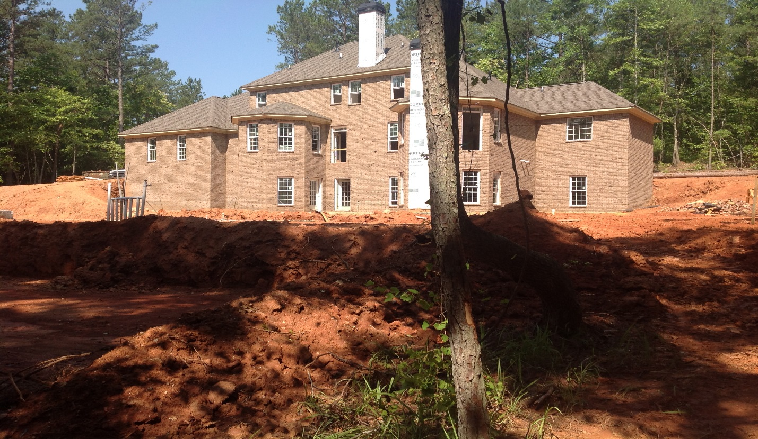
Steel Frame Deck Structure ..
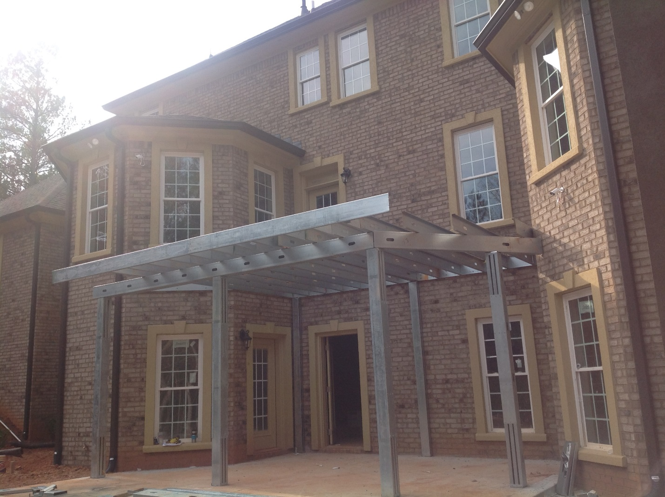

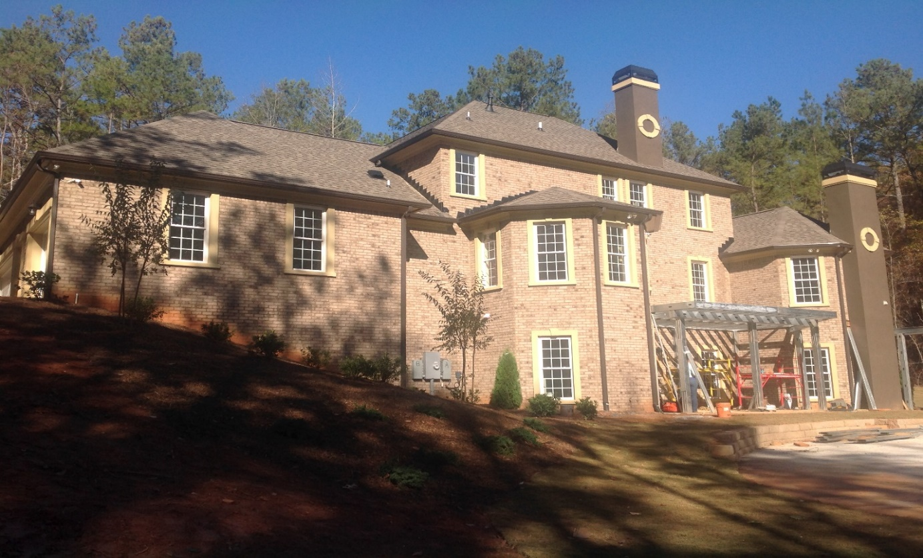
Brazilian Hardwood Decking Fastened From The Bottom of Steel Framing
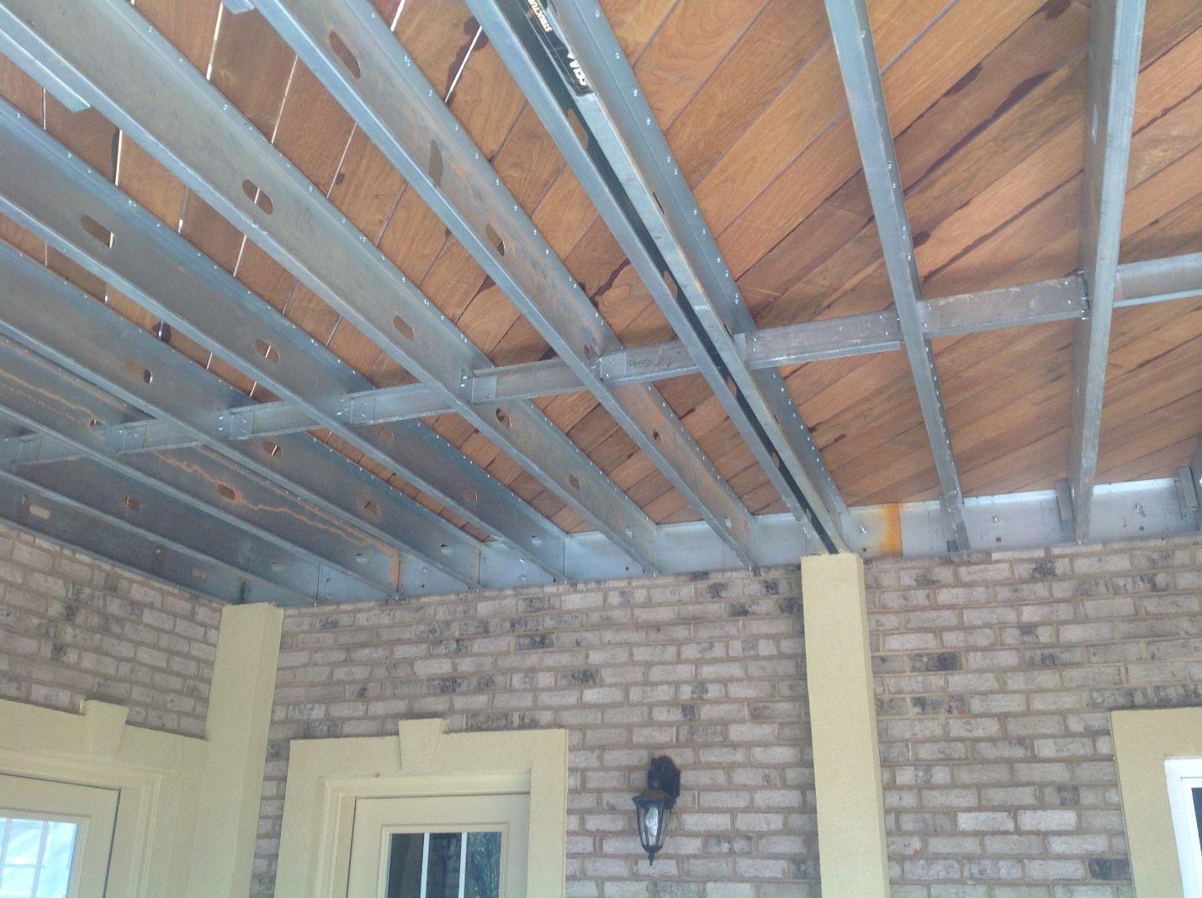

Brazilian Hard Wood Decking…. on Steel-framed Structure.
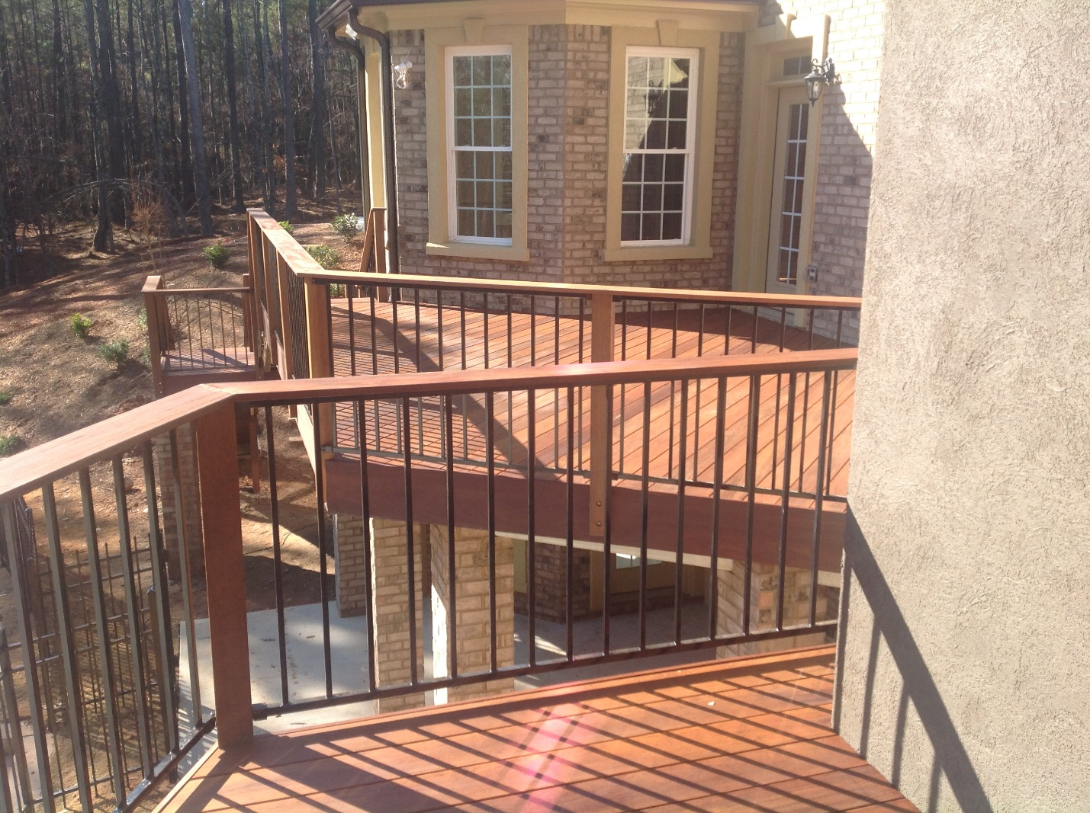
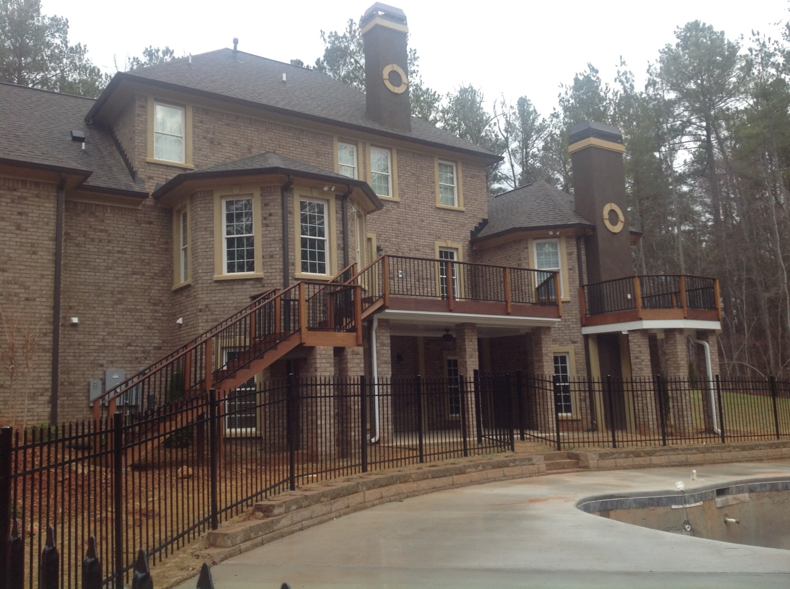

Finished Home
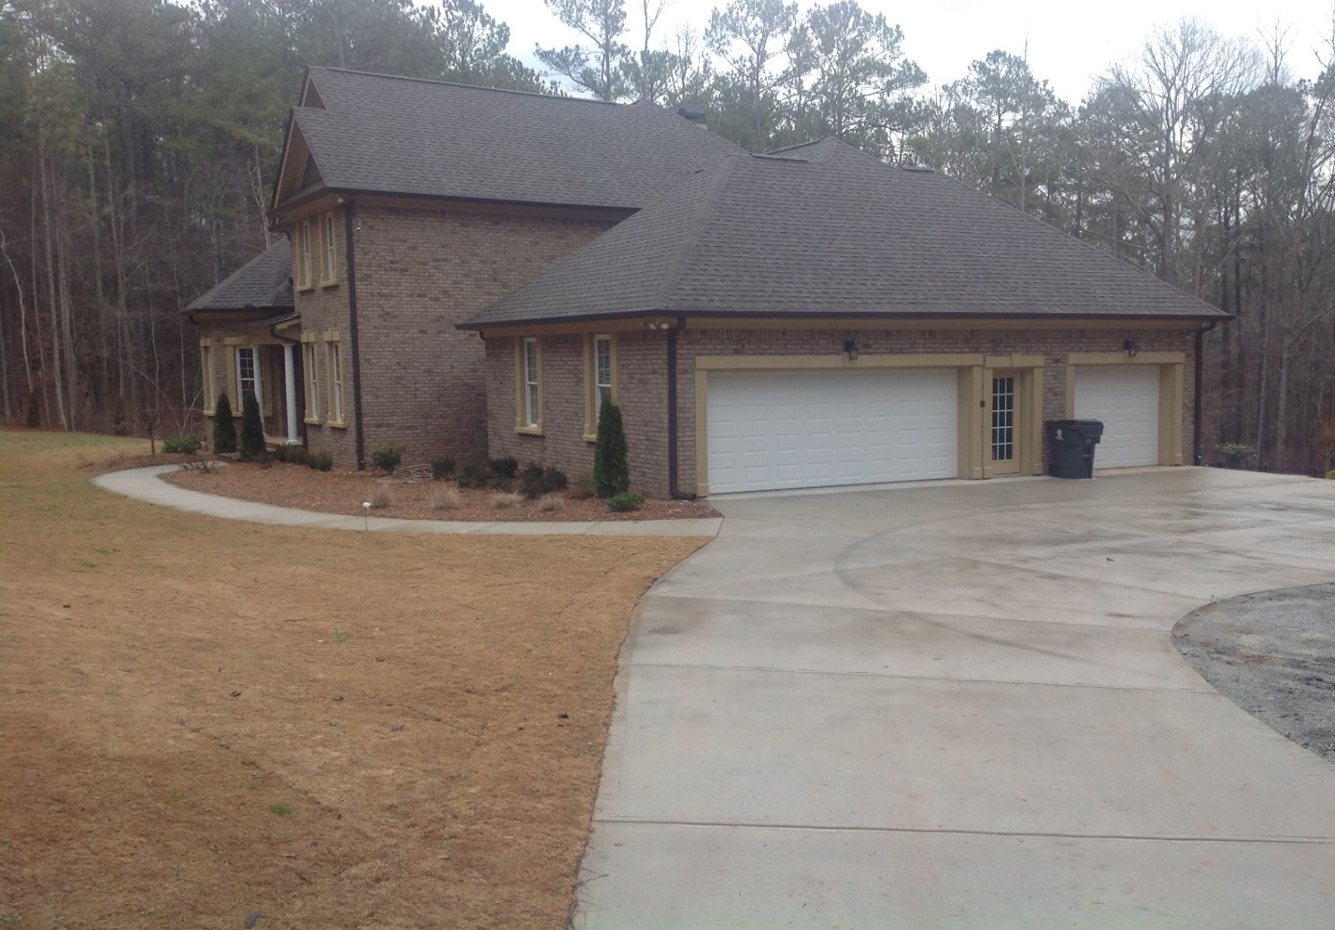
Finished 5000 Sq. Ft. Home

Photo of Eric Dahlin Author: Taken from the Publish Version, of Book. “The Rebuilding & Restoration of America“


